**Python test to fill the data with mean**

**Question**:

1. Create a CSV file named "output.csv" from this below given dataframe.

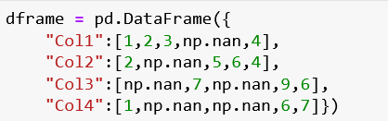

1. Replace all the missing values with the mean for that column
2. Roundup the output upto 3 digits.

